### [**Reindeer Box for a Little Special Treat**](https://papercraftetc.blogspot.com/2018/12/reindeer-box-for-little-special-treat.html)

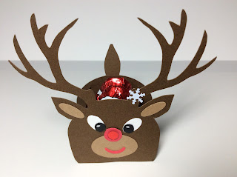

This reindeer box is very easy to make as a last minute gift or as a table decoration. The box dimensions are very small at one inch square. The design can be enlarged if you want to make a bigger box. It holds two pieces of Santa candy. I bought the Santa candy from Aldi and Lidl and my husband says that Aldi's Santa tastes better. The Lidl's Santa is taller and is sized better for the box.

The shiny nose and the snowflake are sequins that I purchased at the Dollar store. I did include a snowflake design if you want to cut one out of a shiny white vinyl. I used card stock to make this design.

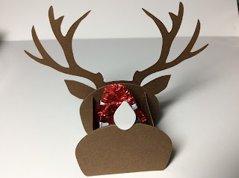

The Reindeer has a white tail.

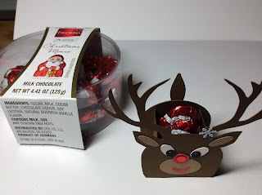

Two pieces of candy can be placed inside the box.